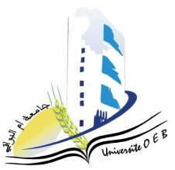**University of Larbi Ben M’Hidi-Oum El Bouaghi**

**Faculty of Exact Sciences and Natural and Life Sciences**

**Department: Material Science**

**Consultation Schedule Semester 3**

**Field: Physics**

**Speciality: Physics**

**2nd year Physics degree**

|  |  |  |  |  |
| --- | --- | --- | --- | --- |
| **Day and date** | **Time** | **Matter** | **Teachers** | **ROOM** |
| Sunday  26-01-2025 | 09h00-09h30 | Geometric Optics and Physics | Lakehal | **C1** |
| Sunday  26-01-2025 | 09h30-10h00 | Physical crystallography | Bouacida |
| Sunday  26-01-2025 | 10h00-10h30 | PhysVibrations and Waves | Seghairi |
| Sunday  26-01-2025 | 10h30-11h00 | Analytical Mechanics | Mellouki |
| Sunday  26-01-2025 | 12h30-13h00 | Series and Differential Equations | Laouadi |
| Sunday  26-01-2025 | 1 3h00-13h30 | Numerical Methods and Programming | Ziar |
| Sunday  26-01-2025 | 13h30-14h00 | Anglais | Boughazi |