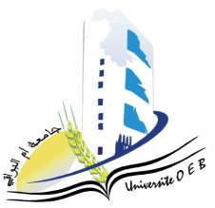**Larbi Ben M'Hidi-Oum El Bouaghi University**

**Faculty of Exact, Natural and Life Sciences**

**Department: Science of Matter**

**Semester 1 consultation Schedule**

**1st year Matter Science**

|  |  |  |  |  |
| --- | --- | --- | --- | --- |
| **Dayetdate** | **Time** | **Subject** | **Teacher** | ROOM |
| sunday  26-01-2025 | 09h00-09h-45 |  | Guechi | **Amphi 10** |
| sunday  26-01-2025 | 09h45-10h30 | Chimie 1 | Hamimed |
| sunday  26-01-2025 | 10h30-11h15 | environnement | anana |
| sunday  26-01-2025 | 12h00-12h30 | anglais | REBIE |
| sunday  26-01-2025 | 12h30-13h15 | informatique | Bounab. |
| sunday  26-01-2025 | 13h15-14h00 | Physique 1 | Farh |

**Academic year2024-2025.**

