May 13, 2026
Department of Geology
Faculty of Earth Sciences and Architecture
University of Oum El Bouaghi

Tectonics II Exam
Choose four questions in addition to Question 4, which is compulsory.
Question 1
-Stress is of two types: hydrostatic and deviatoric, which of the two is responsible for rock deformation? Deviatoric
-What is the name of the geological structure shown in the following figure? Anticline, Syncline
-What type of deformation is responsible for the formation of this structure? Ductile
-Give the names of the elements of this structure indicated by the arrows.
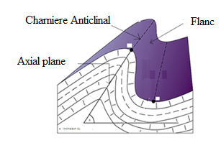
Question 2

1. What is the difference between brittle deformation and ductile deformation?
Brittle = Discontinue, Ductile = Continue, plastique
2. At which structural level does brittle deformation dominate? Superieur
3. Are folds the result of ductile deformation or brittle deformation? Ductile
4. For diagrams A, B, and C:
-What type of fault is shown in A? Normal
-What type of fault is shown in B? Reverse
- What type of fault is shown in C? Decrochement
- Number the stresses on diagrams A, B, and C.

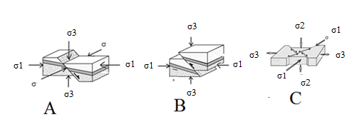
Question 3

1. Give the definition of elastic deformation. Deformation disappears when the stresses cease to act
3. What is the effect of water on the shear strength of rocks? Decreases rock strength
4. What is the effect of increasing hydrostatic pressure on rock failure? Increases resistance to failure
5. Does fluid pressure in the pore spaces of rocks tend to increase or decrease the resistance of rocks to failure? Decreases
6. Rocks can deform either in a ductile or brittle manner depending on the pressure and temperature conditions to which they are subjected. True or false?
7. The deep angle of normal faults is more than 60, that of reverse fault is less than 30: true or false?

Question 4 (compulsory)
-What is the structure in this question? Does it form by brittle or ductile deformation? A fault, Brittle
-Give the names of its different parts from 1 to 7.
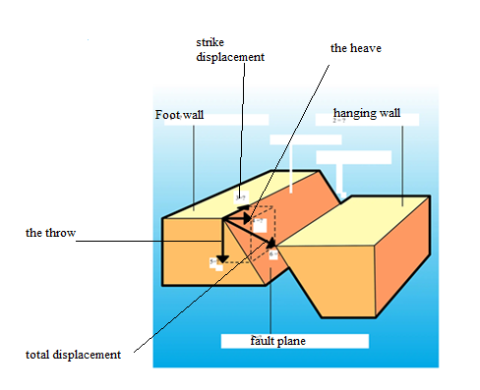
Question 5
1. What are the elementary components of deformation? Translation, rotation, distortion
2. Which of these two figures, a orb, represents pure shear?
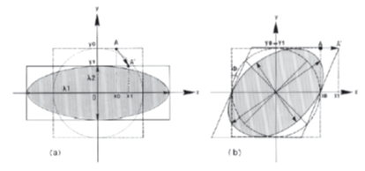

Question 6
A rock sample was subjected to a an extansive stress σ, as shown on the figure bellow.
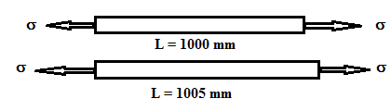
The sample has a initial legngth of 1000 mm, after deformatyion it has become 1005 mm.
- Compute the relatif elongation of the sample ε ? ε = (l-l0)/l0 = 0.005
- Compute the stretch S? S = ε + 1 = 1.005
- Compute the quadratique elongation λ? λ = S² ==> λ ⁼ (1.005)²

