University of Oum Bouaghi Department of Earth Sciences

Exam of Marine Depositional Environment

14 05 26

Questions

The Depositional Environment: Estuaries
Estuaries are dynamic depositional systems that receive and store sediment from
- Rivers or marine depositional or both fluvial (river) and marine (oceanic) sources. (2 marks)
- Defining lagoons: are they deep or shallow or near surface column of water (2 marks)
Lagoons are shallow bodies of water separated from the open ocean by a barrier, such as a barrier island, a sand spit, or a coral reef.
- Fill the gap for each zone with : internal platform - barrier - external platform - supratidal - subtidal – intertidal – open sea (3 marks)

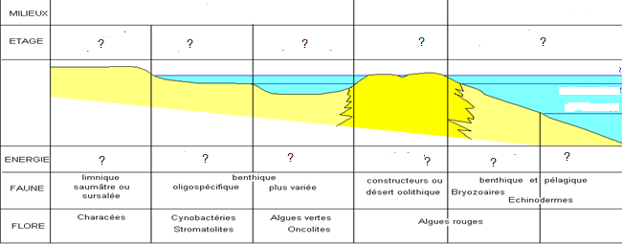

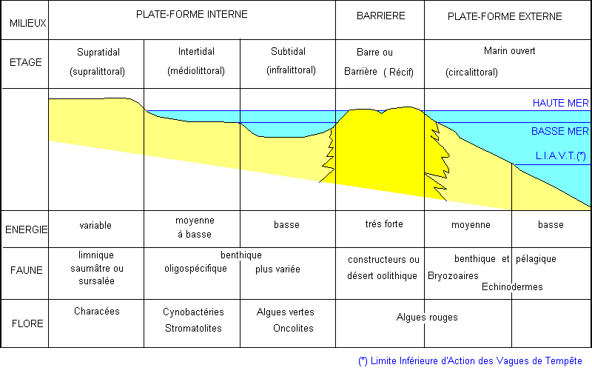

Put the legend corresponding Wave action-Reef zone - Reef Crest For reef zone – Light – Temperature – Depth – Lagoon (4 marks)

What are the Key Coastal Zonation: From Land to Sea: enumerate the different zones (3 marks)
Response:
The coastal environment is categorized into distinct zones based on their relationship to tidal cycles. Each zone presents unique ecological challenges and sedimentary features.
- Supratidal Zone (Supralittoral / Spray Zone)
- Intertidal Zone (Littoral / Foreshore): The high-energy area of constant change.
- Subtidal Zone (Sublittoral / Infratidal): The stable, permanently submerged underwater realm.
- Continental Shelf: The gently sloping submerged margin of the continent.
  - Reef Systems

- Questions define what is A-B-C-D (4 marks)

Responses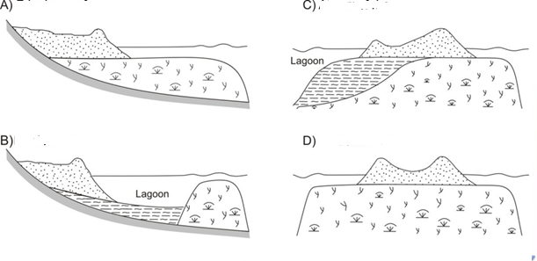

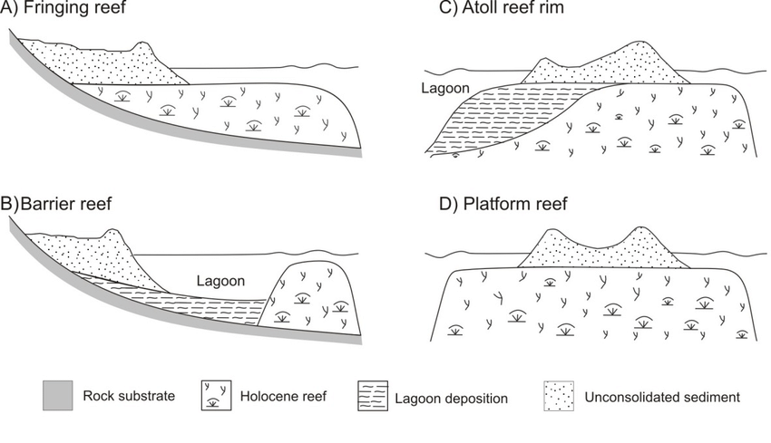

What are the Key Diagenetic Processes: list the different mechanisms (3 marks)
:Response
- Compaction:
- Cementation:.
- Dissolution:.
- Recrystallization:.
- Biological Alteration: Includes bioturbation

- Question list some causes concerning the Eustasy: Global Sea Level Change (3 marks)

Responses Causes of Eustatic Change
- Glacio-eustasy:
- Tectono-eustasy:
- Sedimento-eustasy: Hydrostatic Loading:.

