Department of Geology, Exam and response Marine Environment, 21-05-2024 (Master I)
Detailed Responses
Exam
Question 1 (4 pts)
Select from the list of cementation and recrystallization the right type of answer by inserting it within the exact case:
Fibrous (fibres ou aiguilles isopaques), Drusic Sparitic (sparite drusique), aragonitic squeletal calcification (calcitisation de squelette aragonotique), syntaxial cement (ciment syntaxial), microgranular cement (ciment microgranulaire), fibrous calcite (calcite fibreuse) 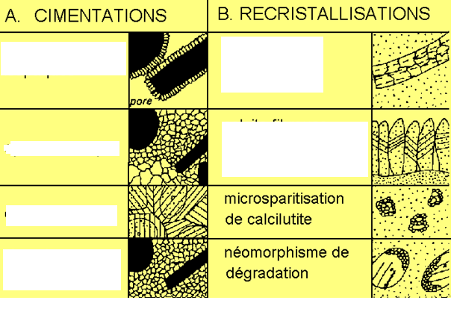
Reponse: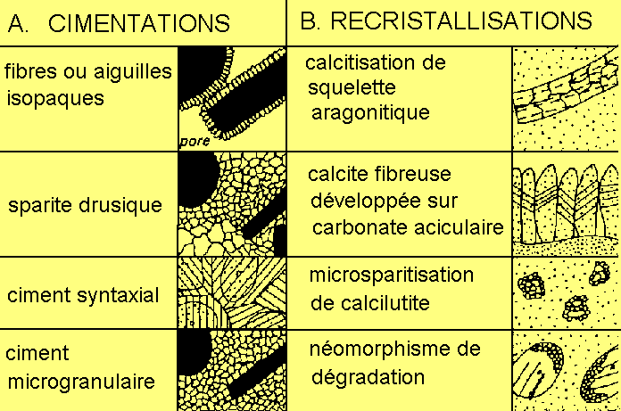
With the following processes: Diagenetic Aspects of carbonate. The main aspects are resulting from the diagenetic effects. It each students is asked to reply in just six gaps more thant this is considered as undesirable.

Question 2 What are the two types of marine sediments and their origin: (3 pts)
Response:
- Detrital with origin from continent fluvial deltaic etc ….and
- chemical water and precipiations in addition to biochemicals including organic and inorganic elements depending on environmental conditions with more explanation in that purpose. Among the effects are the proximity of the continent (rivers delta estuaries) resulting on impact from detrital deposits or their mixture. Far from the neretic we may met the the biocontruction deposits, which are the reefs or barriers and most of the deposits, are bioconstructed ….

Question 3 (7 marks)
Select the right place for the right term according to the list we suggest: photic and aphotic, High water, low water, pelagic, neretic, bathyal, abyssal, benthic, bathyal, (with more explanation)

Detailed response should include some explanation of the different zones/ Establishing the different e.g
Neretic: corresponds to :
Pelagic :……………
Abysal: ……. etc

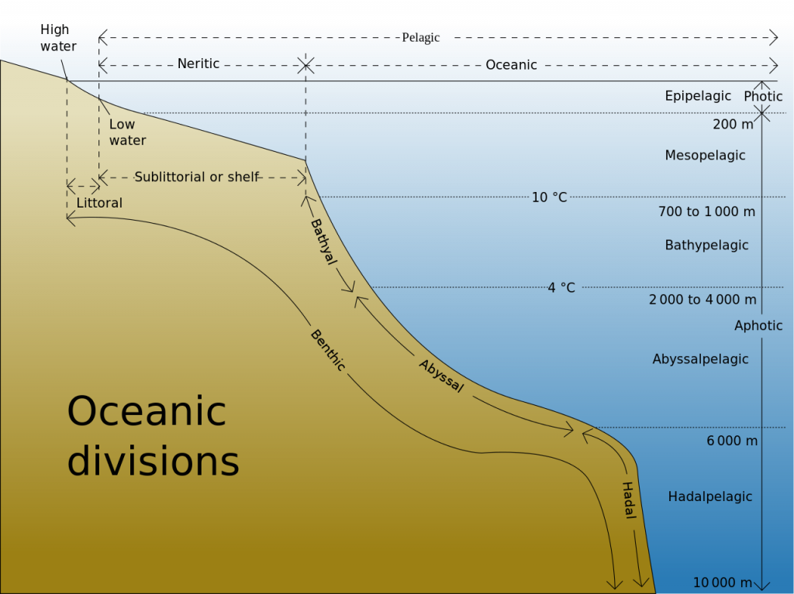

Question 4 (7 pts)
What are the different forms of carbonate (Calcium carbonate): choose the right and complete answer
- Calcium carbonate in the form of aragonite,
- Calcium carbonate in the form of aragonite calcite, magnesium calcite (containing a variable amount of MgCO3)
- Calcium carbonate in the form of aragonite, magnesium calcite (containing a variable amount of MgCO3) and dolomite (Ca,Mg) CO3.
- Complete Response:
- Calcium carbonate in the form of aragonite, magnesium calcite (containing a variable amount of MgCO3) and dolomite (Ca, Mg) CO3 plus ankerite and other minerals. The most important effect is by substitution.
Conditions of generation are listed: according to the diagenetic effects (source dissolution precipitation compaction substitution under the effect of pressure and temperature.

