Larbi Ben M'hidi University, Oum El Bouaghi
Faculty of Earth Sciences and Architecture- Geology Department
Corrected Geology _ exam

First year Licence 2023/2024

- Underline the correct answer(s) (3pts)
- Granite is composed of : Feldspar (0.5pt), Galena, Quartz (0.5pt), Calcite, Orthose (0.5pt), Micas (0.5pt), olivine.
- Sandstone is a rock : Exogenous (0.5pt), Chemical, Detrital (0.5pt).

- What are the most abundant chemical elements in the Earth's crust ? (2pts) SiO₂

- What type of magmatic rock is characterized by a grainy texture ? (2pts) Plutonic magmatic rocks (Intrusives)

- What is the difference between Plutonic rock and Basaltic rock ? (3pts)
Plutonic rocks: formed by the slow cooling of magma at depth (0.5pt). The magma will have time (0.5pt) to crystallize, and the rock will contain large minerals visible to the naked eye (0.5pt).
Volcanic rocks, formed by the rapid cooling of magma at the surface (0.5pt). The minerals will not have time to crystallize properly (0.5pt). Volcanic rocks are therefore characterized by the presence of minerals invisible to the naked eye (0.5pt).

- What is the lower temperature limit of metamorphism ? (1pts) 200°C
- Name two agents in external geodynamics (3pts) Wind, water and gravity
7- Cubic (0.5pt), hexagonal (0.5pt), tetragonal (0.5pt), rhombohedral (0.5pt), orthorhombic (0.5pt), monoclinic (0.5pt) and triclinic (0.5pt).

8. Sedimentary rock originate from the accumulation of sediment (1pt) which are usually deposited in superimposed layers or beds, called strata (1.5pt)

9. In stratigraphy, explain the principle of continuity (2.5pt)
In a basin, sediments are spread in all directions during the course of deposition, but, when traced they show a lateral continuity (0.5pt). When we study sediments, we often find that in a valley the deposits cannot be seen. But they are exposed again across the valley as shown in Figure. This is because the subsequent erosion (0.5pt) along the valley has removed these sediments. But, originally, they were deposited in continuity, which extends up to the limit of the basin, if sufficient amount of sediment is available.
(1.5pts) 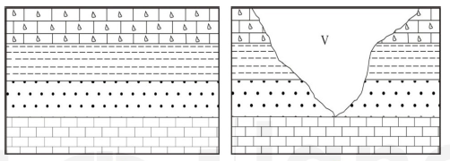

Dr. BOUROUBI

