Midterm exam/project theory 5 January 15th, 2024 (9h00-10h30)
Question 1 (5pts)
The sketch is an important tool in the architectural design process; define the role of this tool in detail.
L’esquisse est un outil important dans le processus de la conception architecturale, définissez le rôle de cet outil en détail.
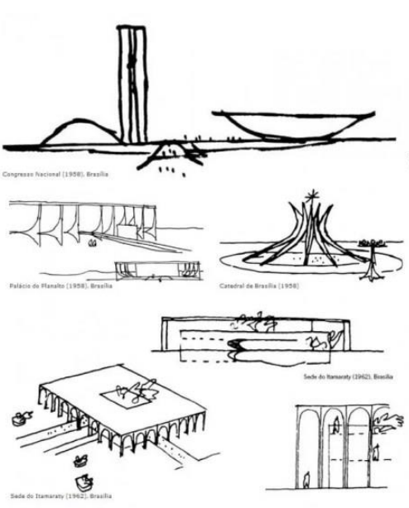
Question 2 (5pts)
The author of these sketches stated in an interview, "Each of my sketches leads to an emblematic example of modernism. Their striking outlines are designed to create immediately recognizable silhouettes on the horizon."
who is the famous author of these sketches, and what are the founding principles of his architectural design theory?
L’auteur de ces esquisses disait lors d’une interview : « Chacune de mes esquisses aboutissent à un exemple emblématique du modernisme. Leurs contours frappants, conçus pour créer des silhouettes immédiatement reconnaissables à l'horizon ».
A qui appartiennent ces esquisses, et quels sont les principes fondateurs de sa théorie de conception architecturale ?
Question 3 (5pts)
What are the urban and architectural analysis parameters presented by the LEMAY architectural firm for the El Menia site development project?
Quels sont lesParamètres d’analyse urbaine et architecturale présentés par le cabinet d’architecture LEMAY pour le projet d’aménagement du site d’El Menia ?

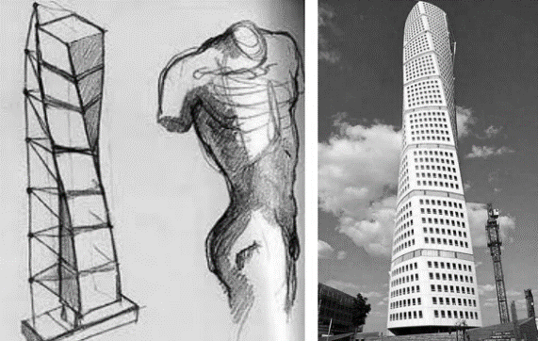
Question 4 (5pts)
The Turning Torso is a residential skyscraper located in Malmö, Sweden. Designed by the Spanish architect Santiago Calatrava, it was completed in 2005. The tower is inspired by the human body in torsion. What is the name of this process of inspiration? and how can it be successfully achieved?
La TurningTorso est un gratte-ciel résidentiel situé à Malmö en Suède. Conçu par l'architecte espagnol Santiago Calatrava, il a été achevé en 2005. La tour s'inspire du corps humain en torsion. Comment appelle-t-on ce processus d’inspiration ? et comment le réussir ?

standard correction
Answer 1 (5pts)
Sketching plays a crucial role in the architectural design process as it allows the architect to explore, communicate, and develop ideas in an initial and free manner. Here are some key roles of sketching in the architectural design process(0.5):
- Creative Exploration: Sketches serve as the primary means for architects to creatively explore different ideas and concepts. They provide a space where architects can think freely, experiment with forms, proportions, and arrangements without the constraints of technical precision.(0.5)
- Rapid Idea Communication: Sketches enable architects to quickly communicate their ideas. They capture the essence of a concept visually and immediately, facilitating the transmission of ideas to team members, clients, and other stakeholders.(0.5)
- Instantaneous Inspiration Capture: Sketches are often created in the moment, capturing the architect's instantaneous inspiration. They serve as a way to grasp ideas before they are lost or forgotten.(0.5)
- Concept Development: Sketches aid in developing an initial concept by giving it a visual form. They allow the architect to see how different parts of the project interact and evolve in space.(0.5)
- Study of the Site and Building Relationship: Sketches can be used to examine the relationship between the building and its site. They help explore how the building integrates into the surrounding context and how it interacts with the landscape.(0.5)
- Reflection on Functionality: By sketching different configurations and layouts, architects can contemplate the functionality of the building. They can explore how the interior and exterior spaces meet the functional needs of the project.(0.5)
- Definition of Architectural Form: Sketches assist in defining the overall architectural form of the project. They allow for experimentation with massing, height, proportions, and other formal characteristics.(0.5)
- Intuitive Response: Sketches enable architects to intuitively respond to emerging ideas. They foster spontaneous thinking and the organic development of the project.(0.5)
- Decision-Making: Sketches serve as a valuable tool for initial decision-making. They help quickly evaluate different options and guide the design process in the desired direction.(0.5)

Answer 2 (5pts)
- These sketches belong to the famous brazilian architect oscarNiemeyer (1pt)
- Oscar Niemeyer's approach to architectural design was characterized by several key principles, reflecting his modernist and avant-garde sensibilities. While he may not have articulated a comprehensive and formalized theory, his body of work and statements offer insights into his design philosophy. Here are some aspects that capture Niemeyer's approach to architectural design:
- Curvilinear Forms: Niemeyer was known for his extensive use of curves and free-flowing shapes in his designs. He believed that curves symbolized freedom, sensuality, and the rejection of the rigidity of straight lines. This preference for organic forms is evident in many of his iconic buildings, where he often avoided right angles.(1pt)
- Sculptural Aesthetics: Niemeyer viewed architecture as a form of sculpture. His buildings wereoften characterized by bold, sculptural shapes and forms that resembled abstract artworks. This approach elevated his structures beyond mere functional edifices to become artistic expressions(1pt)
- Innovative Use of Materials and Technology: Niemeyer wasinterested in pushing the boundaries of architectural technology. He collaboratedcloselywithengineers to develop innovative structural solutions thatallowed for the realization of hisdaring and ambitious designs. His works often featured the use of reinforced concrete, a material that became synonymous with his style.(1pt)
- Oscar Niemeyer was known for his extensive use of raw concrete, specifically reinforced concrete, in his architectural designs. Reinforced concrete involves embedding steel bars or mesh within the concrete to enhance its strength and durability. Niemeyer's affinity for this material was a significant aspect of his modernist and innovative architectural approach.(1pt)

Answer 3 (5pts)
- analysis of the region (1pt)
the host environment(0.5)
socio-cultural context(0.5)
macro analysis(0.5)
- sector analysis (1pt)
immediate environment(0.5)
natural features(0.5)
landscape features(0.5)

Answer 4 (5pts)
- Metaphor (1pts)

• Understanding the Context: Before creating a metaphor, understand the context of the project, including its purpose, location, target audience, and any cultural or social significance associated with it. (1pts)
• Defining the Concept: Identify the concept you want to express. This could be related to the function of the building, its history, its environment, or cultural and symbolic aspects. (1pts)
• Studying the Nature of the Subject: If the metaphor is related to nature, study the specific characteristics of the natural subject you want to incorporate. Understand its forms, textures, colors, and its impact on the environment. (1pts)
• Creating a Narrative: Consider how you can create a narrative through your design. How will the users' experience evolve as they interact with the building? How doesyourmetaphor integrate into this experience?(1pts)

