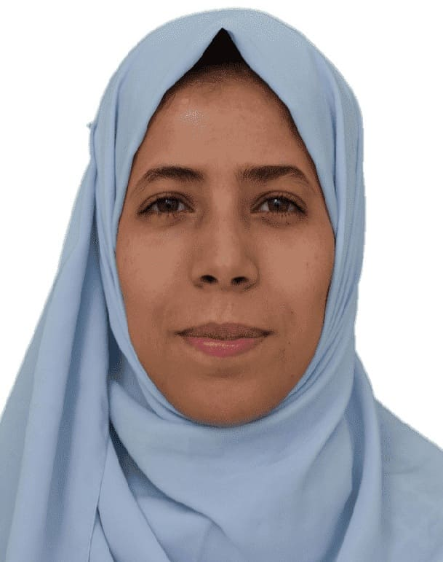to
Curriculum Vitae
Personal information
- Personal
- Prof: Omeiche Khoula
- Professor, faculty of earth science and architecture, department of Geography and Territorial Planning , University of Oum El Bouaghi, Algeria.
- E-mail: omeiche.khoula@univ-oeb.dz
- Mobile: 0795521815
- Researcher identity
- Google Scholar : https://scholar.google.com/citations?user=ghPmhcwAAAAJ&hl=fr
- ReaserchGate : https://www.researchgate.net/profile/Omeiche-Khoula
- ORCID : 0000-0002-4456-820X
- Scopus :
Education
- Ph.D.'s degree in Management of sustainable urban project 2022(Constantine 03)
- Master's degree in Management project 2013 (Constantine 03)
- License's degree in operational project management 2011
Functions and Affiliations
- Professor, ……………………………………….
- Associate professor, X
- Head of Department of Economics, ………………………………………
Teaching modules
City and globalization : Master 01
Management of project: Master 02
Atelier 3eme license
International publications
- …………………………………………
Interests and Qualifications
- Interests: ………………………….
- Qualifications: ………………………………….
- Other: …………………………………………….

