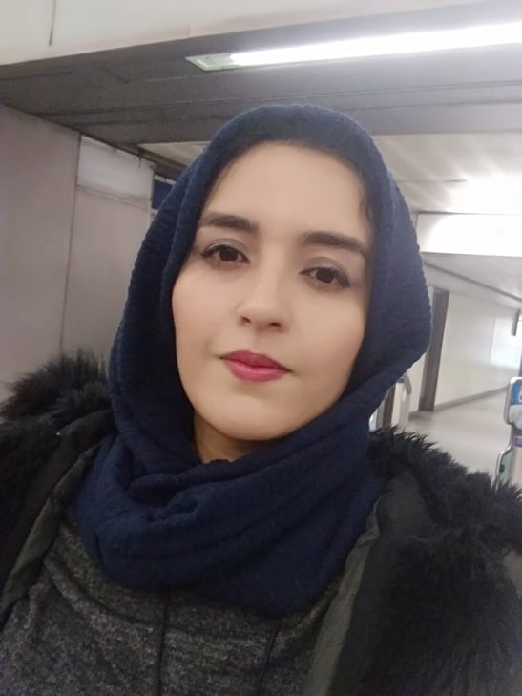 to
Curriculum Vitae
Personal information
- Personal
- Prof: Kadri Meryem
- Assistant Professor, department: Architecture , University of Oum El Bouaghi, Algeria.
- E-mail : kadri.meryem@univ-oeb.dz / kadrimeriem33@yahoo.com
- Mobile : 06 56 54 84 94
- Researcher identity
- Google Scholar : https://scholar.google.fr/citations?view_op=new_articles&hl=fr&imq=Meryem+Kadri
- ResearchGate : https://www.researchgate.net/profile/Meryem_Kadri2
- ORCID : https://orcid.org/0000-0002-3865-2982
- Scopus :
Education
- Ph.D.'s degree in Architecture from the university o 8 May 1945 Guelma
- Master's degree in Architecture and architectural sustainability from the university of OEB
- License's degree in Architecture from the university of OEB
Functions and Affiliations
- Assistant professor Class B at Larbi Ben Mhidi, OEB University
Teaching modules
- Project L1 (12 hrs/Week)
- Module : materials and technology L1 (Interior Design)
International publications
- Kadri, M., Bouchair, A., & Laafer, A. (2022). The contribution of double skin roof coupled with thermo reflective paint to improve thermal and energy performance for the ‘Mozabit’ houses: Case of Beni Isguen’s Ksar in southern Algeria. Energy and Buildings, 256, 111746.
Interests and Qualifications
- Interests: Sustainable architecture.
- Qualifications: Dr of Architecture, Trainer of some thermal and energy simulation software.
- Other: positively influences the future of the architecture department of OEB.

