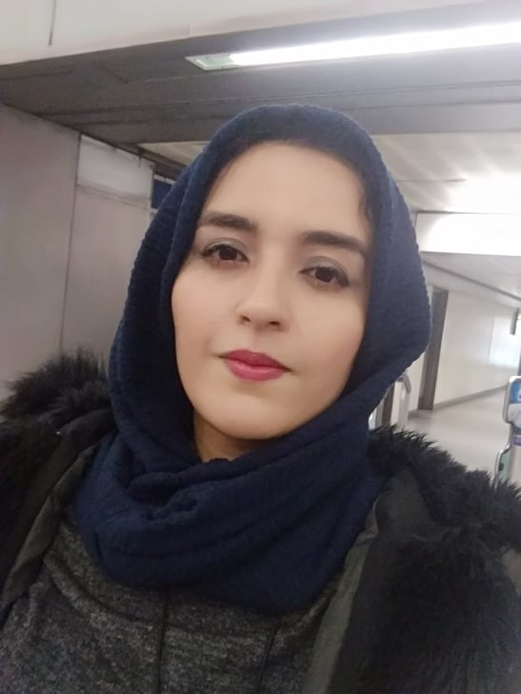 **to**

**Curriculum Vitae**

Personal information

* ***Personal***
* Prof: **Kadri Meryem**
* Assistant Professor, department: **Architecture** , University of Oum El Bouaghi, Algeria.
* E-mail : [kadri.meryem@univ-oeb.dz](mailto:kadri.meryem@univ-oeb.dz) / [kadrimeriem33@yahoo.com](mailto:kadrimeriem33@yahoo.com)
* Mobile : 06 56 54 84 94
* ***Researcher identity***
* Google Scholar : <https://scholar.google.fr/citations?view_op=new_articles&hl=fr&imq=Meryem+Kadri>
* ResearchGate : <https://www.researchgate.net/profile/Meryem_Kadri2>
* ORCID : <https://orcid.org/0000-0002-3865-2982>
* Scopus :

Education

* **Ph.D.'s degree** in Architecture from the university o 8 May 1945 Guelma
* **Master's degree** in Architecture and architectural sustainability from the university of OEB
* **License's degree** in Architecture from the university of OEB

Functions and Affiliations

* Assistant professor Class B at Larbi Ben Mhidi, OEB University

Teaching modules

* Project L1 (12 hrs/Week)
* Module : materials and technology L1 (Interior Design)

International publications

* **Kadri, M.,** Bouchair, A., & Laafer, A. (2022). The contribution of double skin roof coupled with thermo reflective paint to improve thermal and energy performance for the ‘Mozabit’ houses: Case of Beni Isguen’s Ksar in southern Algeria. ***Energy and Buildings***, *256*, 111746.

Interests and Qualifications

* **Interests:** Sustainable architecture.
* **Qualifications:** Dr of Architecture, Trainer of some thermal and energy simulation software.
* **Other:** positively influences the future of the architecture department of OEB.