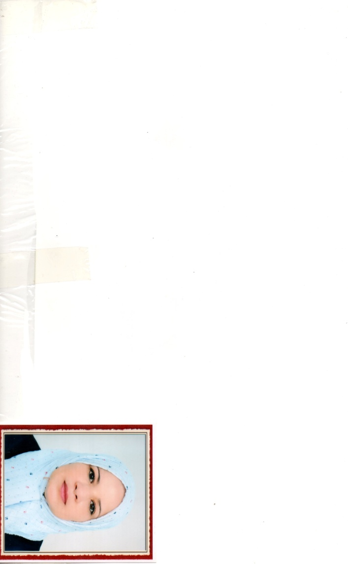

**Curriculum Vitae**

Personal information

* ***Personal***
* Prof: Berrouk Samia
* Professor, department of geology, University of Oum El Bouaghi, Algeria.
* E-mail: berrouk.samia@univ-oeb.dz
* Mobile: 06 64 64 18 82
* ***Researcher identity***
* Google Scholar :https//scholar .google.com/citations?user꓿h325ry4AAAAJ&hl꓿fr
* ReaserchGate : https//www.researchgate.net/profile/Samia-Berrouk
* ORCID :Samia BERROUK (0009-0003-0183-0815) – My ORCID

Education

* **Doctoral student's degree in** 3 years science
* **Magister' s degree in** applied hydrogeology
* **Engineer's degree in**  engineering geology

Functions and Affiliations

* **Associate professor,** B

Teaching modules

* General geology (L1)
* Regional geology (L3)
* Typology of sedimentary structures (M1)