University of Larbi Ben M'Hidi Oum El Bouaghi
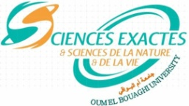
جامعة العربي بن مهيدي أم البواقي
Faculty of Exact Sciences and Natural and Life Sciences
كلية العلوم الدقيقة والعلوم الطبيعية والحياة
Department of Natural and Life Sciences
قسم العلوم الطبيعية والحياة

Exam consultation program for L3 Microbiology (I 05)
 | Sunday 28 | Monday 29 | Tuesday 30
8-9.30 |  |  | Bacterial genetics  Mr. Hamames
9.30-11 |  | Systematic+  Microbial Biotech  Mr. Derouiche
11-12.30 | Myco-algo-virology  Mr. Hamitou |  | Microbial biochemistry  Mr. Djaballah
12.30-14 |  | Scientific English  Miss. Djablkhir | Molecular biology and genetic engineering  Me. Khenouchi
14-15.30

