University of Larbi Ben M'Hidi Oum El Bouaghi
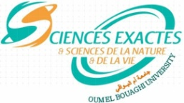
جامعة العربي بن مهيدي أم البواقي
Faculty of Exact Sciences and Natural and Life Sciences
كلية العلوم الدقيقة والعلوم الطبيعية والحياة
Department of Natural and Life Sciences
قسم العلوم الطبيعية والحياة

Exam consultation program for L3 plant Biotechnology

 | Sunday 28 | Monday 29 | Tuesday 30
8-9.30
9.30-10.30 | Multiplication vegetative and  biotechnology  Mrs. Kadi | Genetic bases of biodiversity  (Directed work)  Mr. Grama | Plant physiology  (Course)  Mr. senoussi
10.30-11.30 | Instruments and biology methods and  laboratory safety  Mrs. Kadi | Biostatistics  (Directed work)  Mr. Boudjouref | Scientific English  Miss Khenfar
12.30-14
14-15.30

