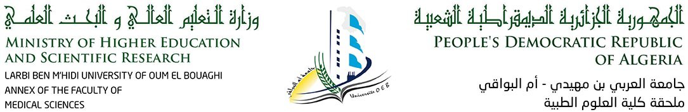

**Time planning of 2nd level Medecine : Endocrinology unit (1st week)**

|  |  |  |  |  |  |  |
| --- | --- | --- | --- | --- | --- | --- |
|  | 8h30 10h | 10h 11h30 | 11h30 13h00 | 13h00 14h30 | 14h30 16h00 | 16h00 17h30 |
| SUNDAY  06/04/2025 |  |  |  | **ANATOMY**  **Dr. DOUS** | **ANATOMY**  **Dr. DOUS** |  |
| MONDAY  07/04/2025 | **BIOCHEMISTRY**  **Dr. BOUFAMA** | **BIOCHEMISTRY**  **Dr. BOUFAMA** |  | **GENETICS**  **Dr. MECHERI** | **GENETICS**  **Dr. MECHERI** |  |
| TUESDAY  08/04/2025 | **HISTOLOGY** | **HISTOLOGY** |  |  |  |  |
| WEDNESDAY  09/04/2025 | **PHYSIOLOGY**  **Dr. KHELIFI** | **PHYSIOLOGY**  **Dr. KHELIFI** |  |  |  |  |
| THURSDAY  10/04/2025 | **BIOCHEMISTRY**  **Dr. BENATTALAH** | **BIOCHEMISTRY**  **Dr. BENATTALAH** |  |  | |  |  |



**Time planning 2nd level Medecine: Endocrinology unit (2nd week)**

|  |  |  |  |  |  |  |
| --- | --- | --- | --- | --- | --- | --- |
|  | 8h30 10h | 10h 11h30 | 11h30 13h00 | 13h00 14h30 | 14h30 16h00 | 16h00 17h30 |
| SUNDAY  13/04/2025 | **BIOCHEMISTRY**  **Dr. FERGA** | **BIOCHEMISTRY**  **Dr. FERGA** |  | **TD/TP** | **TD/TP** |  |
| MONDAY  14/04/2025 | **ANATOMY**  **Dr. DOUS** | **ANATOMY**  **Dr. DOUS** |  | **GENETICS**  **Dr. MECHERI** | **GENETICS**  **Dr. MECHERI** |  |
| TUESDAY  15/04/2025 | **PHYSIOLOGY** | **PHYSIOLOGY** |  | **SOINS GENERAUX** | **SOINS GENERAUX** |  |
| WEDNESDAY  16/04/2025 | **HISTOLOGY** | **HISTOLOGY** |  | **TP Anatomie**  **Dr. Filali** | **TP Anatomie**  **Dr. Filali** |  |
| THURSDAY  17/04/2025 | **GENETICS**  **Dr. MECHERI** | **GENETICS**  **Dr. MECHERI** |  | **TD/TP** | **TD/TP** |  |