**University of Larbi Ben M’hidi Oum El Bouaghi**

Faculty of Earth sciences and Architecture **Module: Terminology**

Architecture Department **Time Allowed: 1h30**

**1st year Infography May 12th, 2025**

**2nd Semester Exam Answer Key**

**Activity One ( 05 pts):**

1. Identify the storage solutions shown in the following pictures.

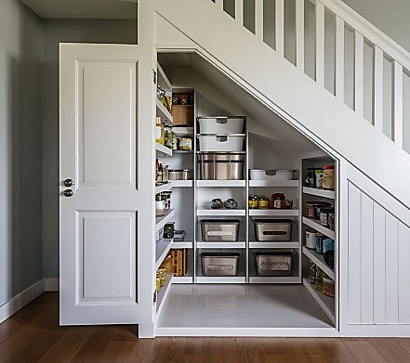 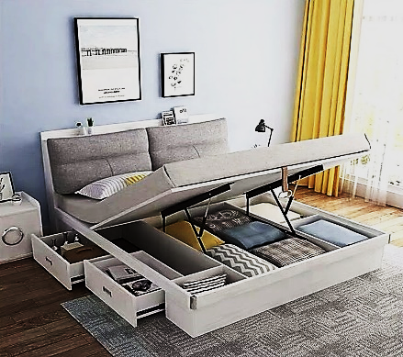 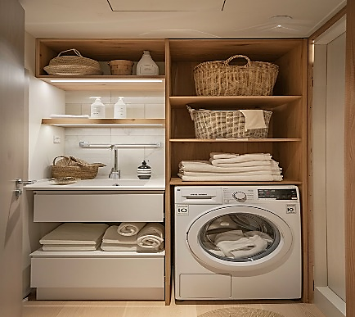

1. **Built-In Storage B- Multi-Functional Furniture C- Vertical Storage**
2. How does storage affect the functionality of an interior space?

* Storage enhances functionality by organizing items, reducing clutter, maximizing space usage, and improving movement and comfort within the space.

**Activity two ( 05 pts):** Answer **True (T)** or **False (F)** and correct the wrong ones**.**

1. A roof plan includes slopes, drainage systems, and chimney. **True**
2. Zoning makes a space feel ~~more~~ less confusing and ~~less~~ more functional. **False**
3. Presentation drawings are often colored and rendered for visual appeal. **True**
4. Vinyl and PVC are examples of ~~natural~~ artificial materials. **False**
5. Sketch drawings are useful for exploring early design ideas. **True**

**Activity Three ( 05 pts):** Answer the following questions.

1. What is a sustainable building material?

A sustainable building material is a material that is environmentally friendly throughout its life cycle, and supports long-term ecological balance. It has a low environmental impact.

1. Provide three characteristics that make a materials sustainable.

• Renewable or recyclable

• Low energy consumption in production

• Non-toxic and durable

1. Give three examples of sustainable materials.

• Bamboo

• Recycled steel

• Cork

**Activity Four (05 pts):**

Complete the table below by writing a brief description of the function or purpose of each type of architectural drawing:

|  |  |
| --- | --- |
| **Drawing Type** | **Description** |
| Site Plan | Shows the entire plot of land, building position, surrounding features, and access. |
| Sketch | A quick, freehand drawing to explore ideas or initial concepts. |
| Floor Plan | A horizontal cut view showing room layout, walls, doors, and furniture. |
| Section | A vertical cut view showing the interior structure (walls, floors, heights). |
| Elevation | A flat view of one side of the building showing the façade and vertical elements. |

**Good Luck.**