**University of Larbi Ben M’hidi Oum El Bouaghi**

Faculty of Earth sciences and Architecture **Module: Terminology**

Architecture Department **Time Allowed: 1h30**

1st year Architecture and Interior Design **May 14th, 2025**

**2nd Semester Exam Answer Key**

**Activity One (04 pts):**

1. **Identify** the type of architectural drawings shown in the following pictures, and **explain** the difference between them.

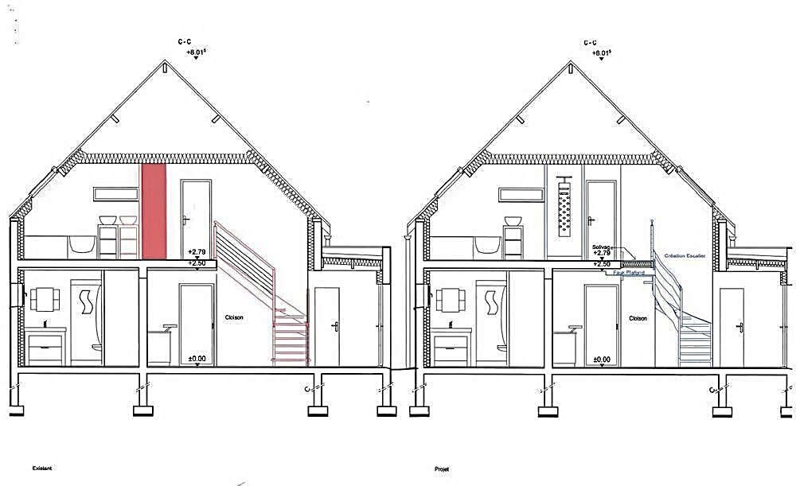 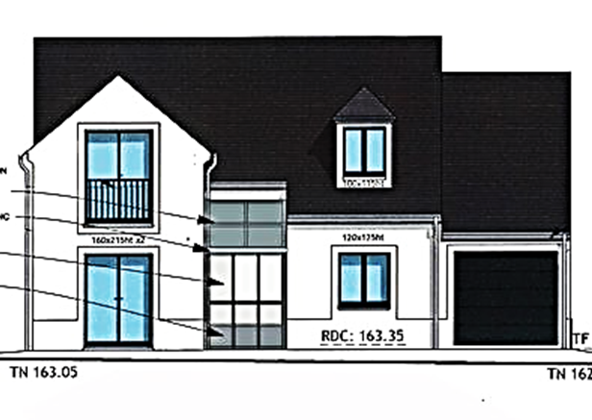

1. **Section B-Elevation**

• **Section:** A vertical cut-through view showing the **interior structure** of a building (e.g., walls, floors, stairs). Section shows the inside.

• **Elevation:** A flat view of the **exterior** of one side of a building (e.g., doors, windows, façade). Elevation shows the outside.

**Activity Two ( 05 pts):**

1. Complete the following table by selecting the appropriate materials:

|  |  |  |
| --- | --- | --- |
| **Flooring Materials** | **Wall Materials** | **Ceiling Materials** |
| 1. Ceramic tiles 2. Hardwood 3. Laminate 4. Marble   **N.B: you can choose other materials.** | 1. Paint 2. Wallpaper 3. Wood paneling 4. Stone | 1. Gypsum Board 2. Acoustic tiles 3. PVC panels 4. Wooden beams |

1. What are the main criteria for choosing good building materials?

Durability /Cost-effectiveness /Sustainability / Aesthetic appeal / Availability /Safety and fire resistance

**Activity Three ( 04 pts):**

**Explain “Functionality and Flow” in interior design:**

Functionality and flow refer to how efficiently a space is used and how easily people can move through it. A functional space meets user needs, while good flow ensures a natural, uninterrupted movement between zones, improving comfort, usability, and the overall experience of the space.

**Activity Four ( 07 pts):** Choose the correct answers.

1. **We can use the space under stairs for the following purposes:**
2. Mini Home Library ;
3. It is preferable to leave it empty;
4. Hidden Storage Cabinet;
5. **To make better use of corners, we can use them for the following purposes:**
6. Corner Bookshelves;
7. Coffee corner;
8. Corner Entryway;
9. **It is essential to select building materials according to:**
10. Sustainability;
11. Aesthetic;
12. Low-Quality;
13. **Sketches are often done in the early stages of design to study:**
14. Precise measurements;
15. Form and Proportion;
16. Spatial relationship;
17. **Sustainable materials are:**
18. Natural and Renewable materials;
19. Recycled Materials;
20. High-performance materials;
21. **The benefit of using natural light in space is:**
22. To increase energy use;
23. To make the room darker;
24. To improve mood and to save energy;
25. **Why do designers use colour psychology?**
26. to help designers understand how colours affect mood and feeling.
27. To make the room bigger;
28. To know which colours are trendy

**Good Luck**