**University Larbi Ben Mhidi OEB,**

**Department of Geology, Exam Marine Environment, 17-04-2025 (Master I)**

**With typical correction**

**Question 1 (4.5 pts)**

1. **What is the definition of ACD and CCD**

**R Aragonite Compensation Depth and Calcite Compensation Depth**

1. what is the difference between authigenic and detrital

R precipitation of the mineral formation in place and detrital is sourced from erosion and desagregation

1. What are the 3 major components of sediments

R Detrital biogenic and authigenic

**Question 2 (6 marks):**

1. **what are the typical coral reefs according to the graph**

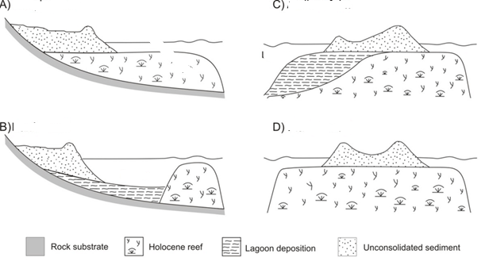

**Response**

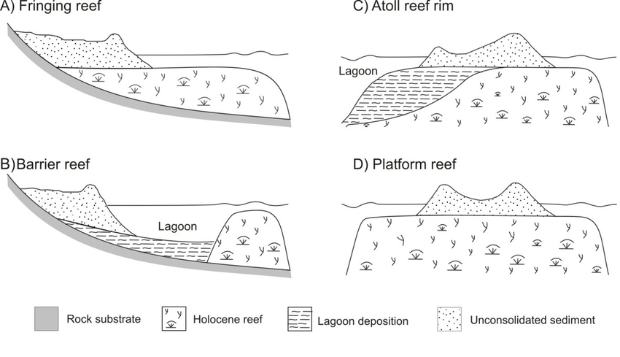

(c)Tides (high and low heights), corals building the bioconstruction (algaes and bryozoans)

**Question 3 (3 marks)**

1. **What are the different environments for the case of shallow marine with barrier**

* **Continental Shelves reefs carbonate platforms and lagoons**

1. **What are the different environments for the case of deep marine**

**R Abyssal, Continental slope and oceanic trench**

**Question 4 (7 marks)**

1. Locate Backshore, Subtidal, Supratidal and Intertidal

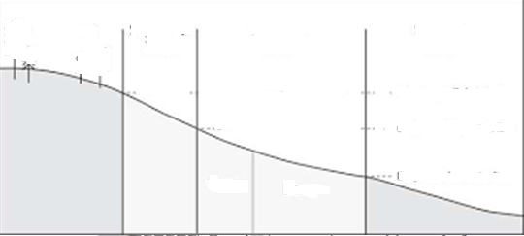

R

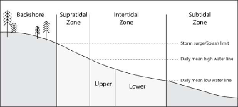

1. Using your own sketch locate the **Neretic Bentic and Pelagic zones**