**University Larbi Ben Mhidi OEB,**

**Department of Geology, Exam English, 18-04-2025 (Master I)**

**Succint for typical correction**

**Question 1 (5marks)**

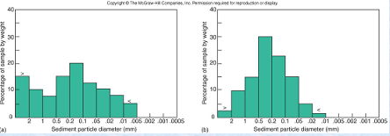

**Describe the two graphs:**

Are they uniform in their grain size distribution (for the two graphs)

**R/ Graph 1 consists on polymodal with the grain size very reduced from 0 up to 0.006 Microns (the highest distribution is about 20%)**

**Graph 2 almost unimodal starting from 0 up to 0.01 Microns (The highest distribution is about 32%)**

**Question 2 (5 marks)**

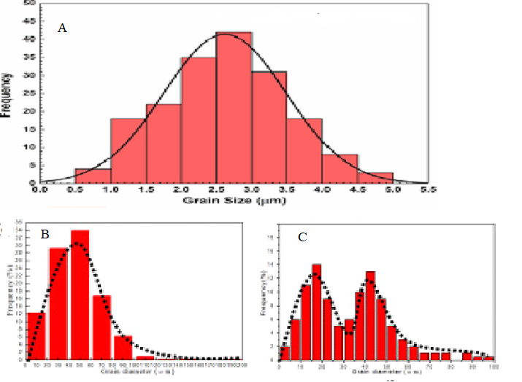

According to the Gaphs: A, B, C

* which of them is, assymetrical and unimodal, polymodal and symetrical and Unimodal and symmetrical
* R

B - C and A

**Question 3 (10 marks)**

**Title: Depositional Environnements and their processus**

Chemical sedimentary rocks form by chemical precipitation that begins when water traveling through rock dissolves some of the minerals. These minerals are carried away from their source and eventually redeposited, or precipitated, when the water evaporates away.

The processes by which sediments are changed into rock are complex, but can be simplified into two processes, called compaction and cementation. Rounded sediment grains (ooliths) bound together with crystalline calcite.

Detrital sedimentary rocks are formed when an existing rock is eroded or broken down into pieces by water, wind, or ice. These fragments are transported to a new location, deposited, and begin the process of lithification.

the marine depositional environment refers to environments associated with saltwater seas and oceans. Transitional depositional environments include environments such as deltas, where freshwater rivers empty into saltwater seas or oceans. These environments form the landforms around the coast

In marine depositional environment, there are three primary facies associated with deep marine sedimentary deposition: mud limestone, which is primarily composed of calcareous ooze from calcareous planktic organisms; chert, which is primarily siliceous ooze from siliceous planktic organisms; and red mud

Q- 1 What can be the accurate title you may suggest: (scratch the wrong ones)

1. Marine depositional environment
2. Detrital deposition and its process
3. Chemical depositional processes
4. Sedimentary Deposition environments and their characteristics

**R/ d**

Q- 2

1. the delta considered as marine or
2. continental or
3. another Environment type (nominate it)

**R / C transitional**

Q – 3

What are the main components of marine environment and their origin (choose the significant response)

1. Siliceous originated from detrital deposits
2. Siliceous originated from siliceous planktonic organisms
3. Calcareous ooze and siliceous ooze

**R**

1. **Calcareous ooze and siliceous oozes**

Question 4

What are the two main procedures responsible for the sediments to become rocks according to the text

1. Compaction and cementation
2. Erosion and cementation
3. Cementation and dissolution

**R;**

1. **Compaction and cementation**