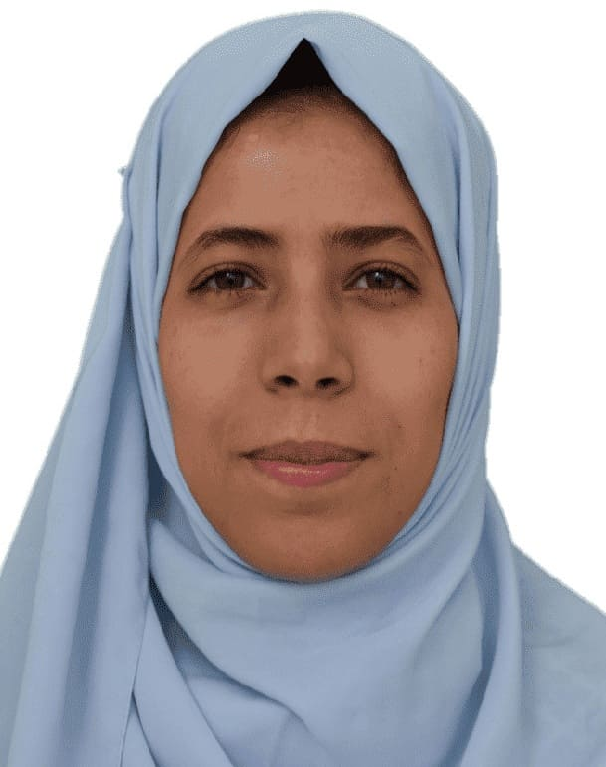**to**

**Curriculum Vitae**

Personal information

* ***Personal***
* Prof: Omeiche Khoula
* Professor, faculty of earth science and architecture, department of Geography and Territorial Planning , University of Oum El Bouaghi, Algeria.
* E-mail: omeiche.khoula@univ-oeb.dz
* Mobile: 0795521815
* ***Researcher identity***
* Google Scholar : https://scholar.google.com/citations?user=ghPmhcwAAAAJ&hl=fr
* ReaserchGate : https://www.researchgate.net/profile/Omeiche-Khoula
* ORCID : 0000-0002-4456-820X
* Scopus :

Education

* **Ph.D.'s degree** in Management of sustainable urban project 2022(Constantine 03)
* **Master's degree** in Management project 2013 (Constantine 03)
* **License's degree** in operational project management 2011

Functions and Affiliations

* **Professor,** ……………………………………….
* **Associate professor,** X
* **Head of Department of Economics**, ………………………………………

Teaching modules

City and globalization : Master 01

Management of project: Master 02

Atelier 3eme  license

International publications

* ***…………………………………………***

Interests and Qualifications

* **Interests:** ………………………….
* **Qualifications: ………………………………….**
* **Other:** …………………………………………….