**University of Oum Boughi Departement of Geology**

**1st Term 2023 - 2024**

**Exam in Sedimentary Structures typology**

* **Question 1: fill the gaps (1, 2, 3, 4, 5, 6) and define the type of cross bedding (3 and 4)**

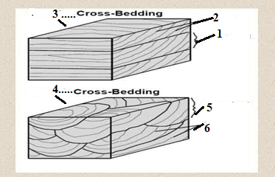

Response 1 with more explanation

Two main types of cross-bedding can be defined by the geometry of the foreset and their bounding surfaces: i. **Planar or Tabular planar cross-bedding**. **Trough cross-bedding**.

tabular planar cross-bedding, planar foreset are bounded above and below by **sub parallel sub horizontalset boundaries**.

**Trough cross bedding, upward concave foreset lie within erosion scours which are elongated parallel to current flow,**(fig below)

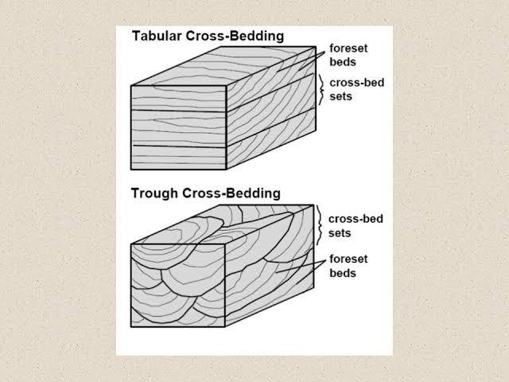

* Question 2 What type of ripples (title) and what is its current origin

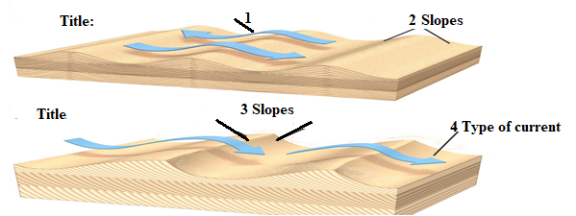

* **Question 3.**

List 2 sedimentary structures originated as predepositional 2 figures as syndepositional and 2 figures as postdepositional

**Reponse:**

Channels Sole marks Flute marks Groove marks (erosional in origin)

Ripple marks Cross bedding Massive Flat-bedding (including parting lineation) Graded bedding Lamination Cross-lamination (origin predominantly depositional)

Postdepositional: Slump Slide Convolute lamination Convolute bedding Recumbent foresets Load structures (predominantlt deformation)

Question 4: Put the legend for 1 and 4 (sequence or order), regarding the age of both sequences what is the tendency from 3 to 2 (age..)

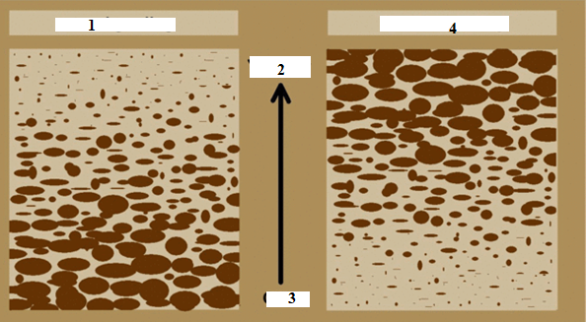

Response:

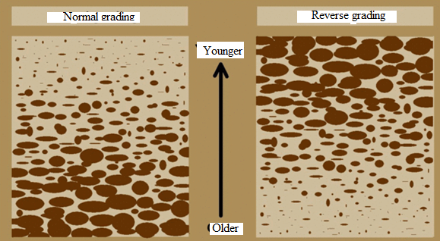

* Question 5

The secondary sedimenrtary structures are these chemical sedimentary structures deposited by what type of chemical processes

R/ Chemical processes, such as oxidation-reduction, precipitation, evaporation, etc, form R SEDIMENTARY STRUCTURES Chemical sedimentary structures.

* **Question 6**

List 2Predepositional structures, and what is their main origin

(interbed) Channels Sole marks Flute marks Groove marks Predominantly erosional II. Syndepositiona list 2 structures

R Flat-bedding ( Graded bedding Cross-bedding Lamination Cross-lamination

Postdepositional (deform interbed and intrabed structures)

* Question 7What types of the structure bedding and what is the **type of current (1)** and the title of each structure and what type of slope (2 steeper or gentle) for both case



**Reponse**

Current direction and origine (waves) with **symmetricalripples originated from waves indicating the two directions (the lee side and stoss side), are symmetrical (see figure).**

**Assymetrical ripples and originated from current withassymetrie between the lee side and stoss side and the crest (they are assymetrical) (see figure)**

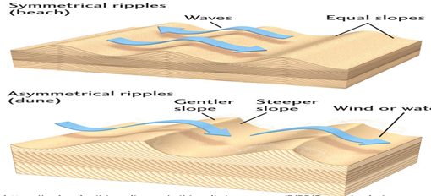

* **Question 7For defining the depositional environment list which sedimentary rock**

**parameterswe can use**

**Response**

To identify depositional environments investigation is conducted towards examine grain size, composition, sorting, bed-surface marks, cross bedding, and fossils to identify a depositional environment.

Question 6

1. What type of structure and its cause of formation

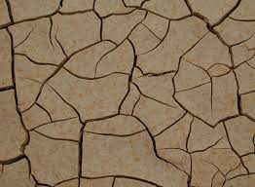

**Response :Mud Cracks and causes interpretation, dewatering indicates the loss of water**

1. **What type of sedimentary structures**

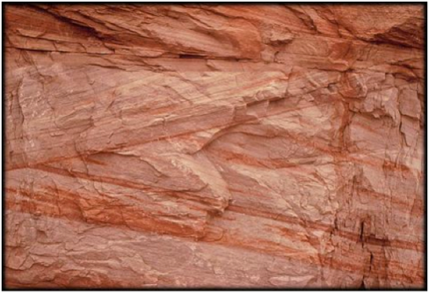

Cross-beddedsandstone own to variation of dipping angle (lee and stoss side)

Cross-bedding is formed by the downstream migration of bedforms such as ripples or dunes in a flowing fluid.: change in angle during deposition. The fluid flow causes sand grains to saltate up the stoss (upstream) side of the bedform and collect at the peak until the angle of repose is reached